**---------------Task 1---------------**

Git Jenkins RHEL 8 Docker

Task 1 given By Mr. Vimal Daga Sir

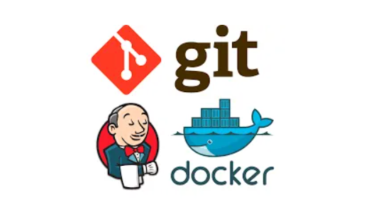

**Task Description :-**

Task 1

JOB#1

If Developer push to dev branch then Jenkins will fetch from dev and deploy on dev-docker environment.

JOB#2

If Developer push to master branch then Jenkins will fetch from master and deploy on master-docke environment.

both dev-docker and master-docker environment are on different docker containers.

JOB#3

Manually the QA team will check (test) for the website running in dev-docker env++ironment. If it is running fine then Jenkins will merge the dev branch to master branch and trigger #job 2

**Pre-requisites For This Project :-**

- Base OS in my case it is Windows 10 and On the Top of Windows 10 I am using Red Hat Enterprise Linux (RHEL 8 ) with the Help of Virtual Box

- In This RHEL we need Jenkins to installed and setup to be completedd so that we can use it in our ptoject.

This is the code which is pushed by Developer From Git Bash to GitHub on 2 different branches i.e. master and dev branch now we ill use this in Jeknins to use them and merge branches to merge the code ..

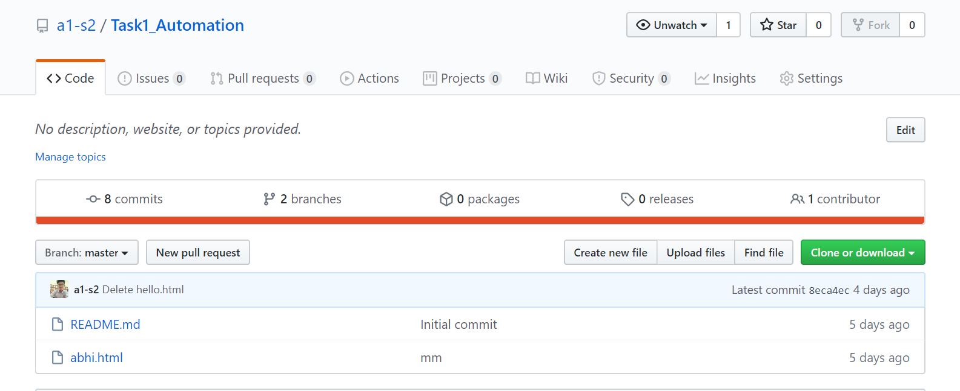

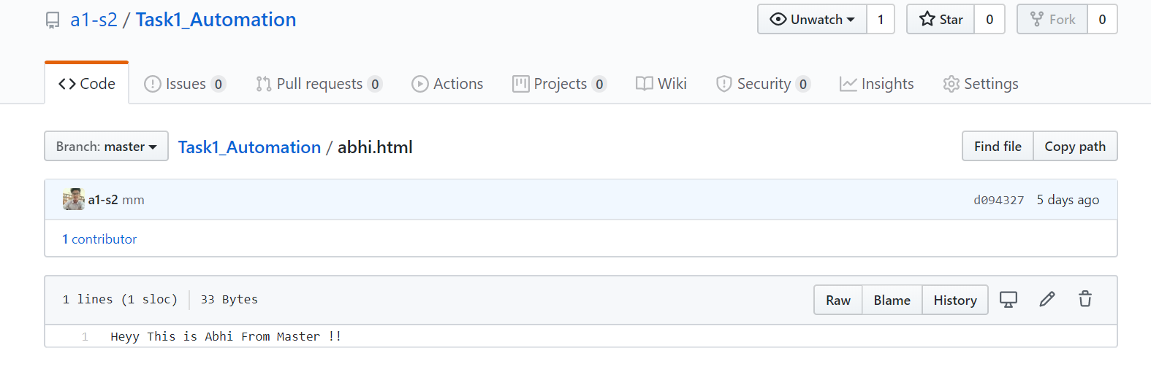

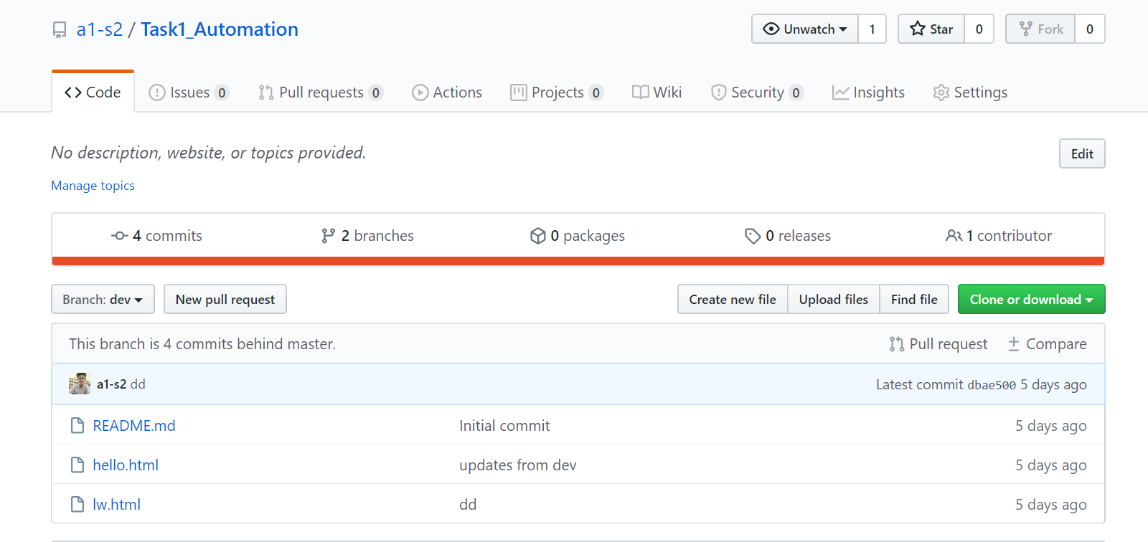

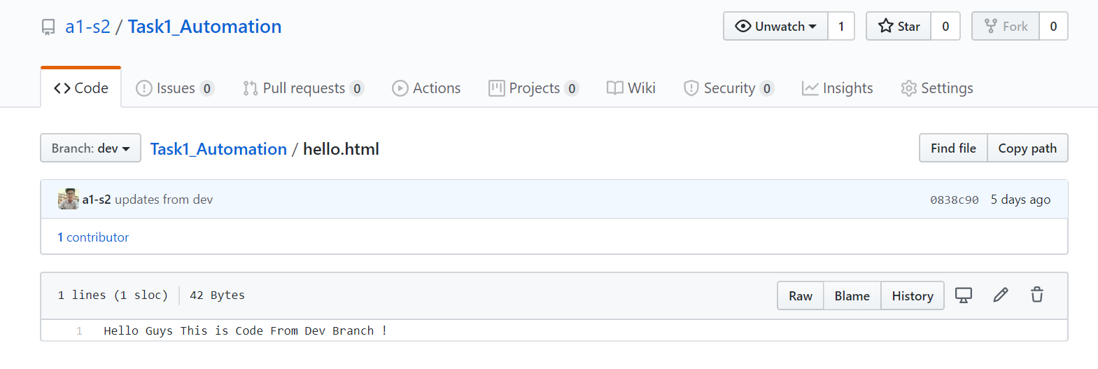

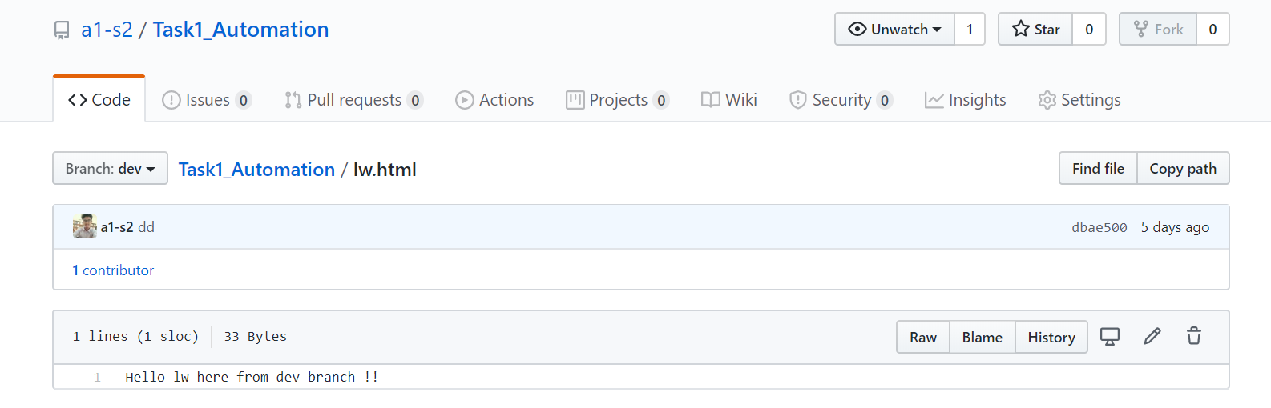

Now I am Creating Jenkins job to Perform this task as shown in below image .

JOB 1 :-

This Job will copy the code from master branch to git-master directory if this directory is created otherwise it will create it this directory and then the data will be copied to the directory and then we are going to launch one container using httpdnimage so that it will transfer this page to container usr/local/apache2/htdocs/ folder and th/en it will be deployed there .

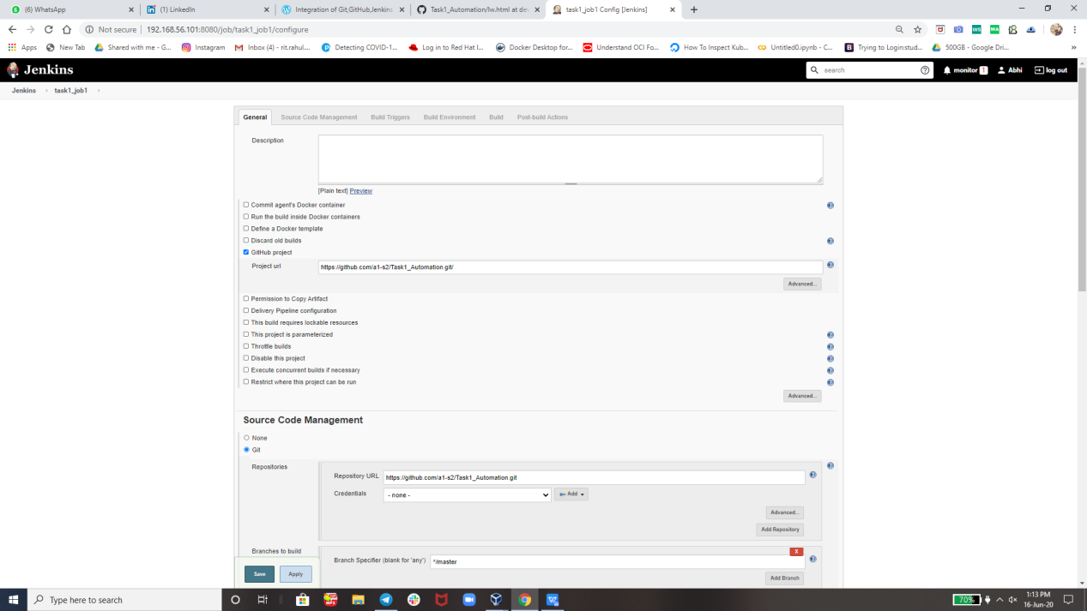

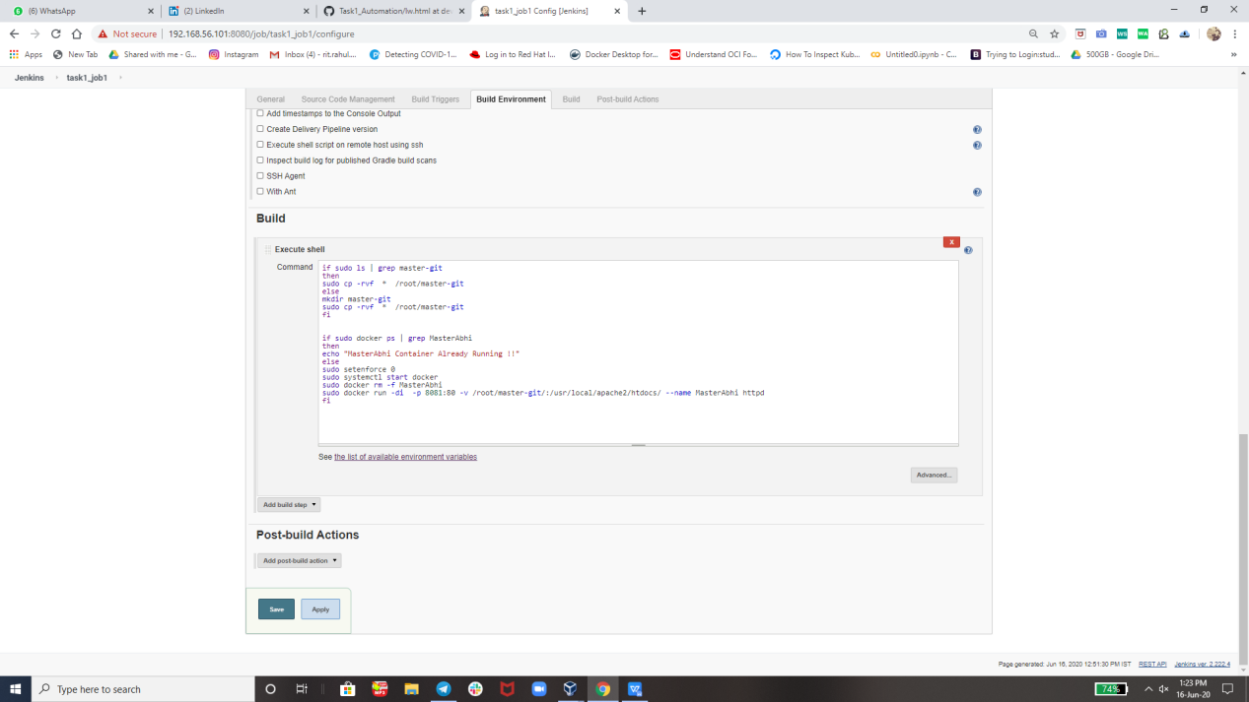

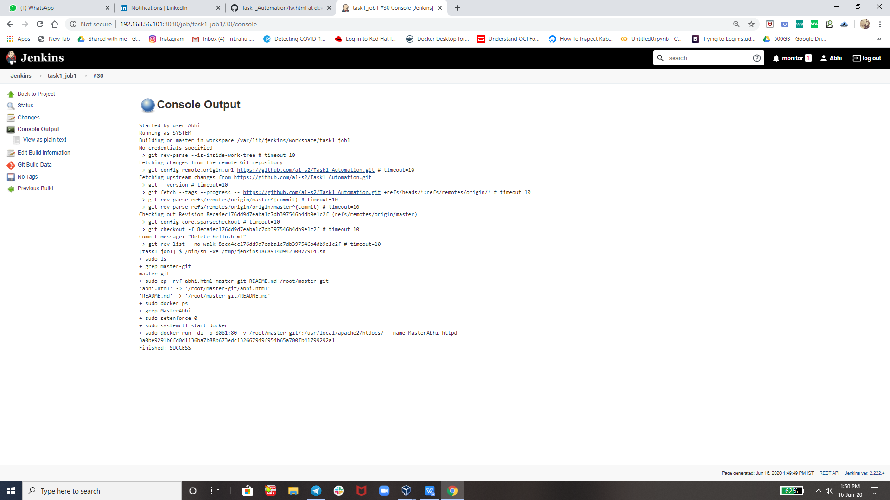

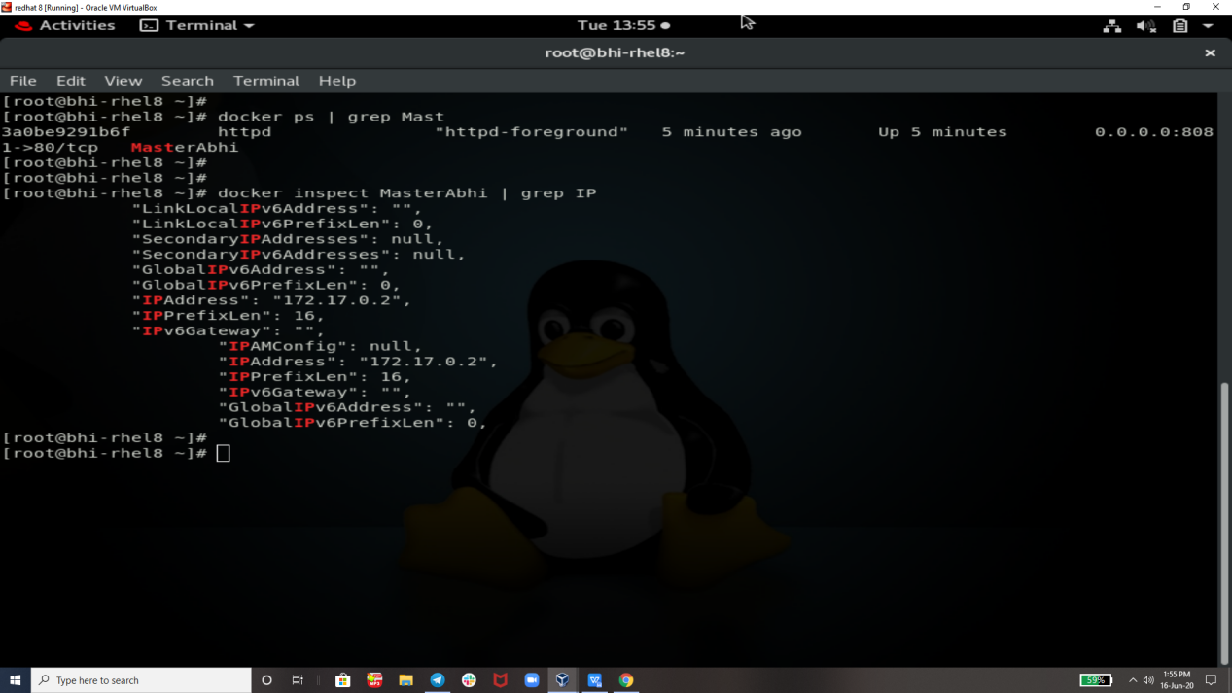

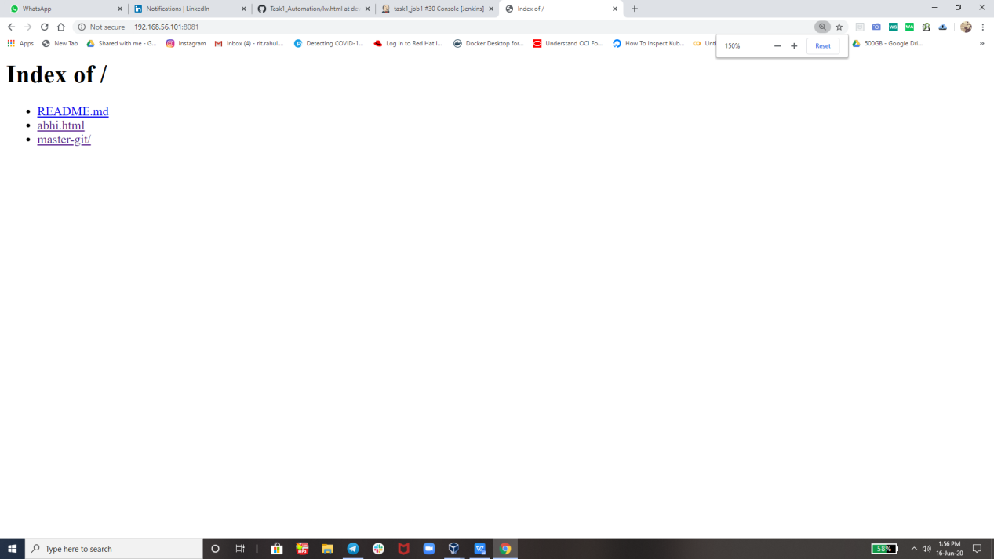

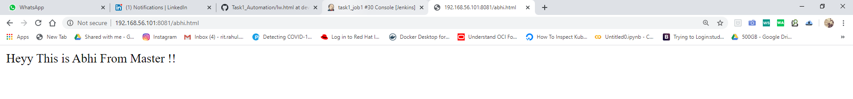

Now t will trigger job 2 automatically ..

JOB 2 :-

This Job will copy the code from the github from dev branch and deploy on DevAbhi Container

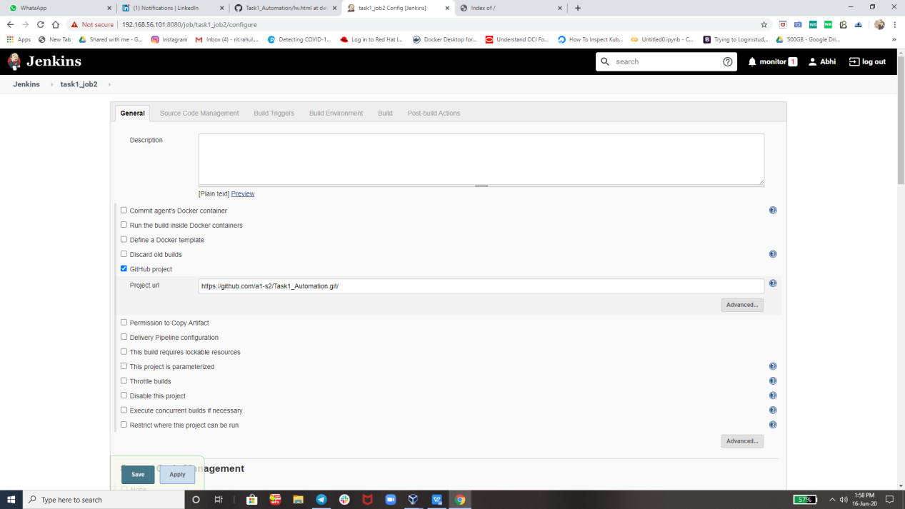

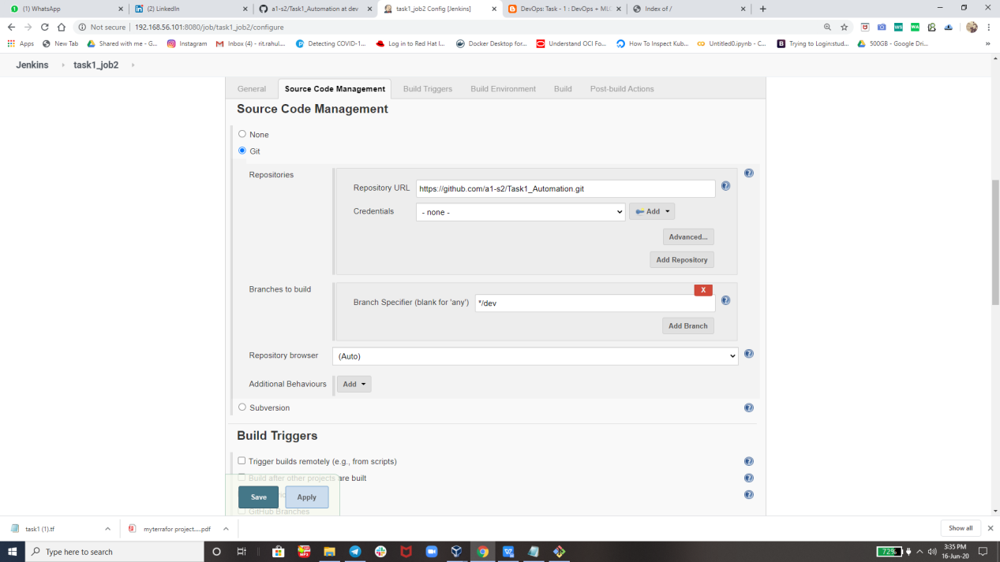

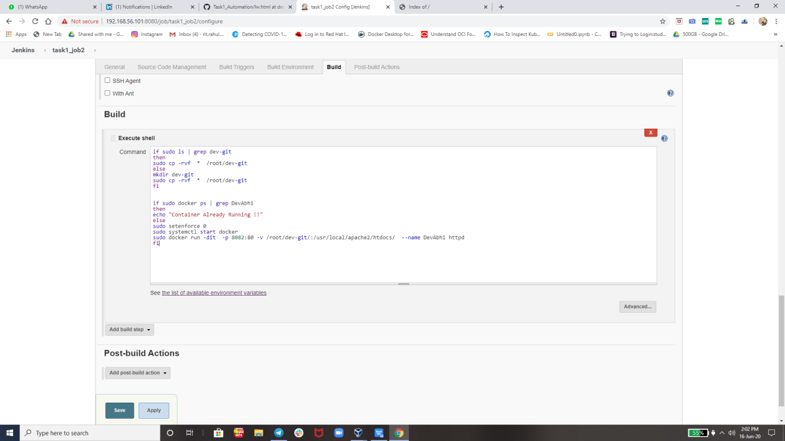

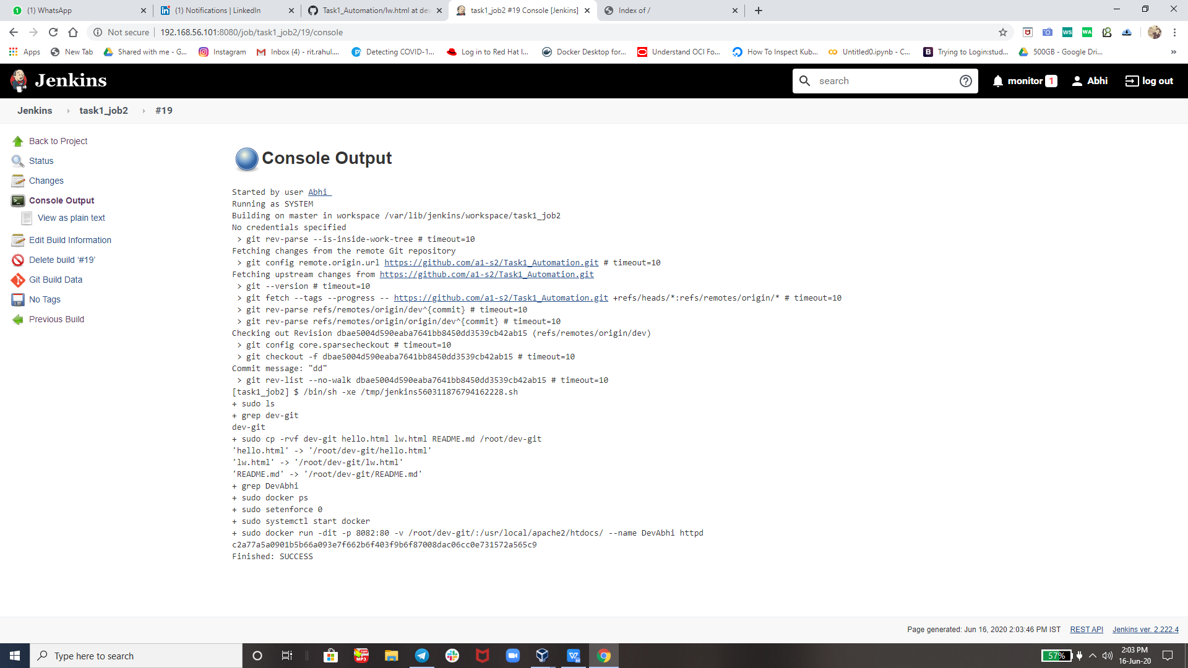

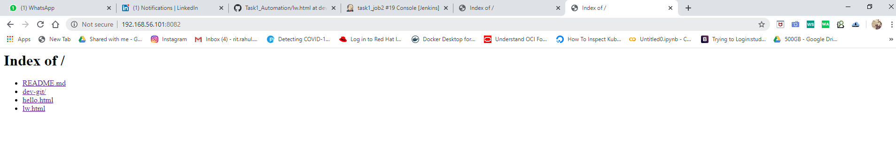

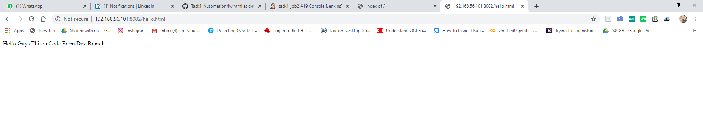

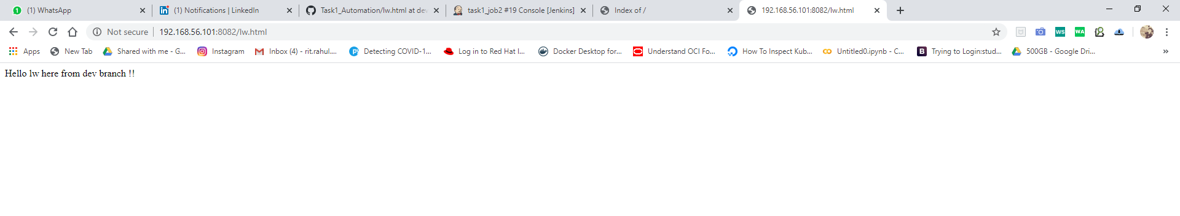

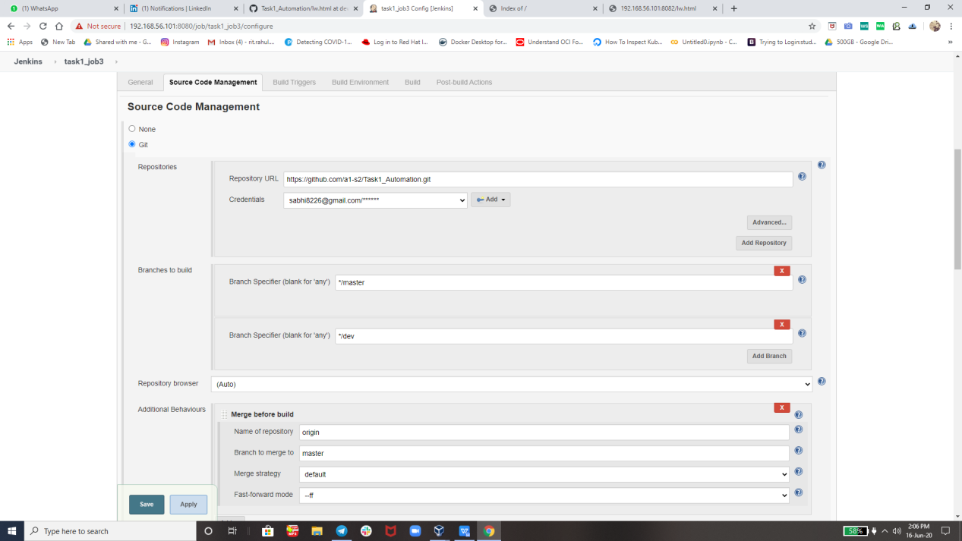

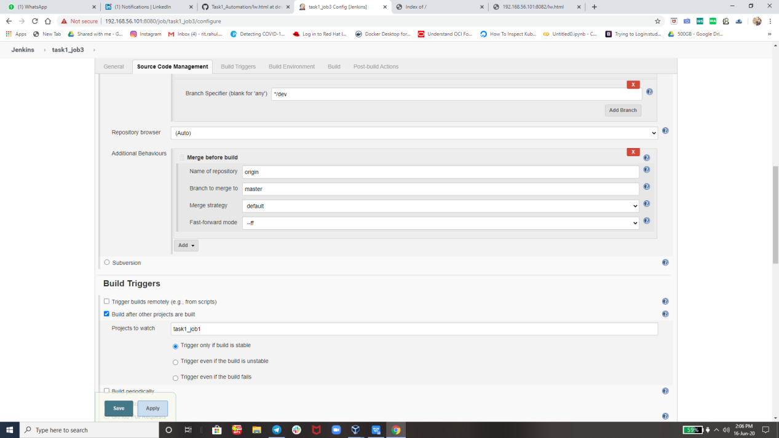

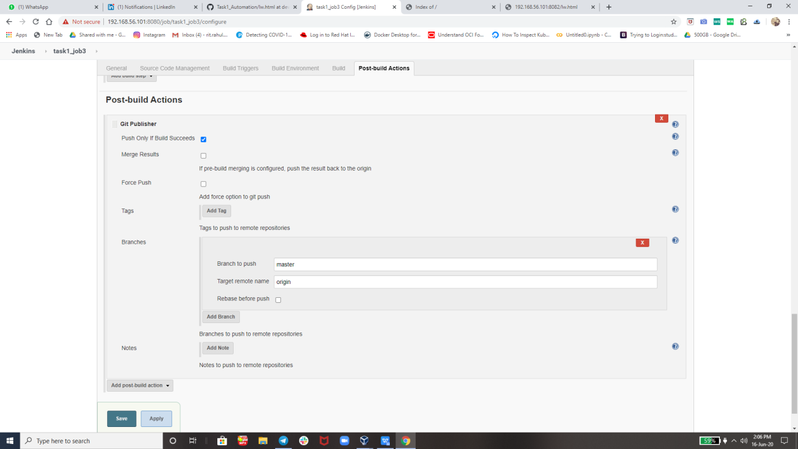

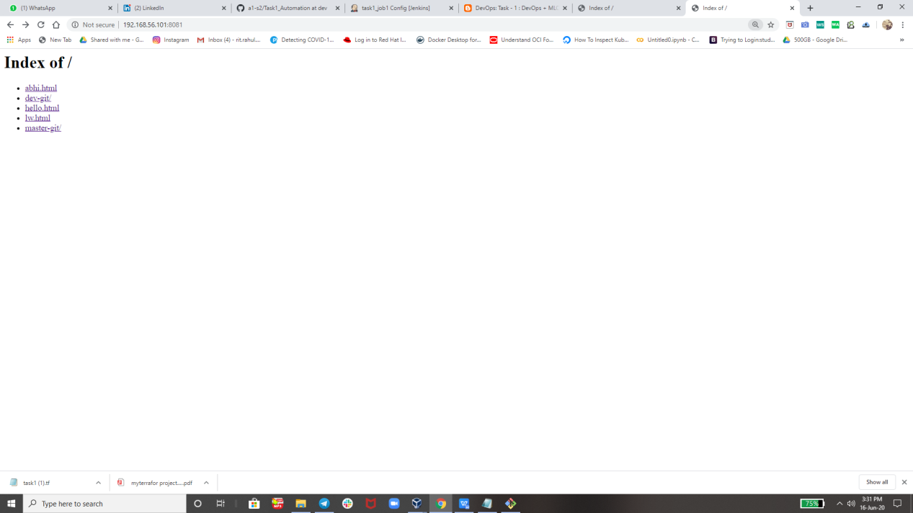

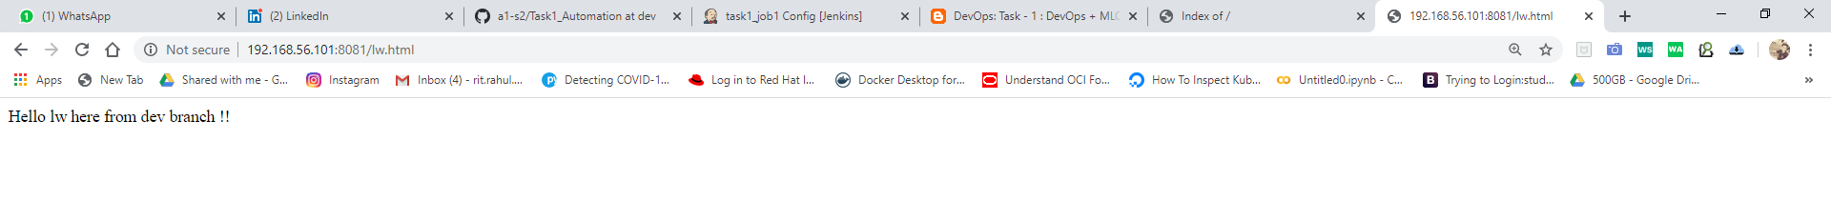

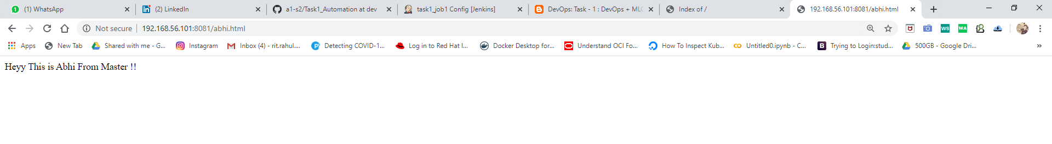

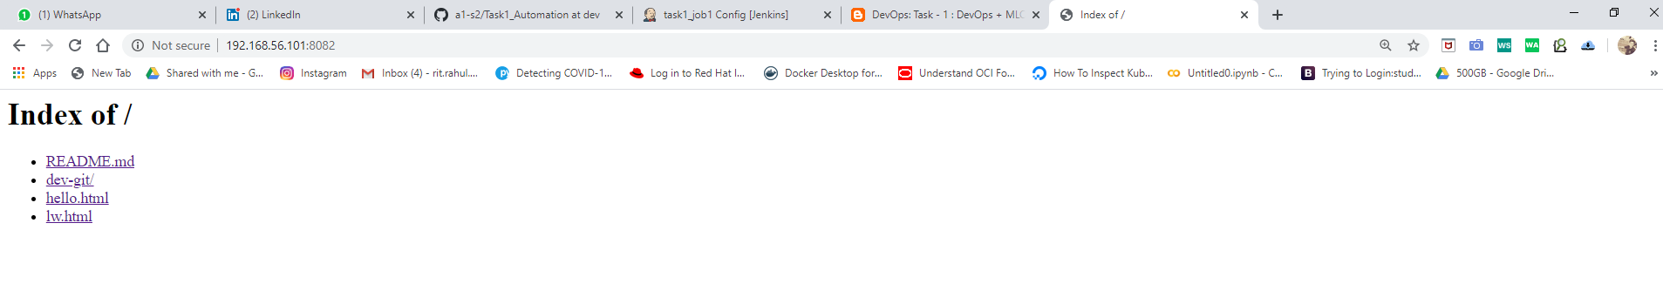

Thats all its done !!.

**All Thanks tO my Mentor The World Record Holder Mr. Vimal Daga Sir**

**Thank you vimal sir for teaching us such an great tools technology like RHEL 8, Jenkins, Docker, git and many more. So that today i am capable of creating such an Great ProJecT.**

**Thank you EveryOne For Reading !**